上海师范大学国际学生在线申请指南
International Students Online Application Guide
Shanghai Normal University
在线申请网址/online application Website：https://apply.shnu.edu.cn

Step 1：注册/ Register
登录我校国际学生在线申请网站，注册（需要用电子邮件注册，注册后会收到一封邮件，点击后才能激活账户，才算正式完成注册），推荐使用IE10和Chrome浏览器。
Open the application website and register with your e-mail. IE10 and Chrome is recommended. You will receive a confirmation e-mail once you finish registration. You need click the link in the e-mail to activate your account.
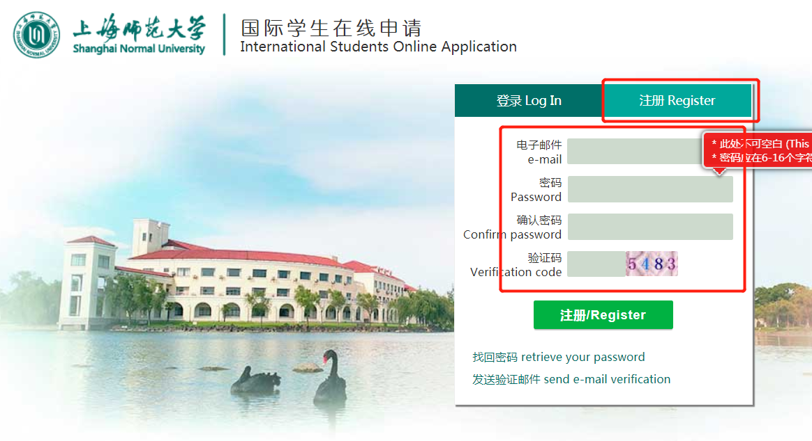

Step 2：登录/log in
用注册的电子邮件登录在线申请网站 Log in with your e-mail
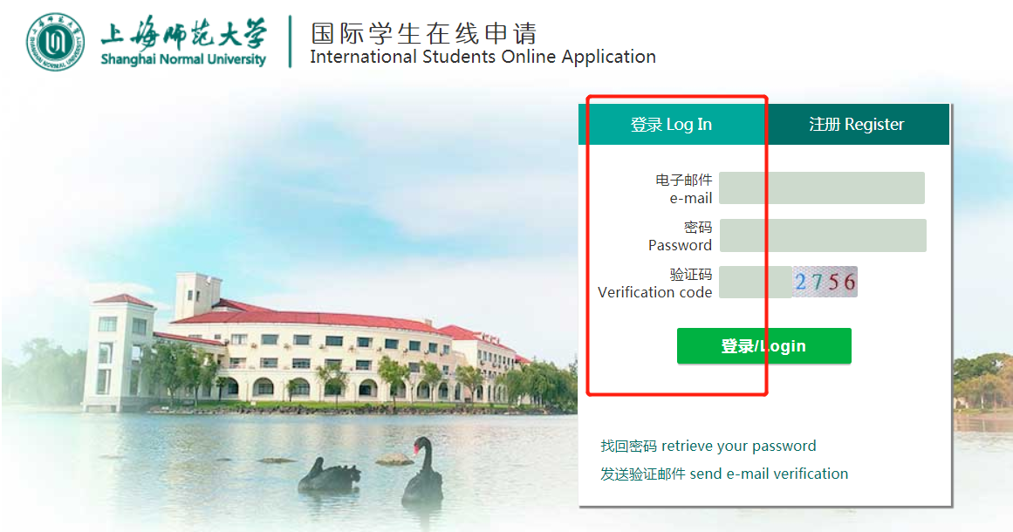

Step 3：点击新申请/Click the New Application
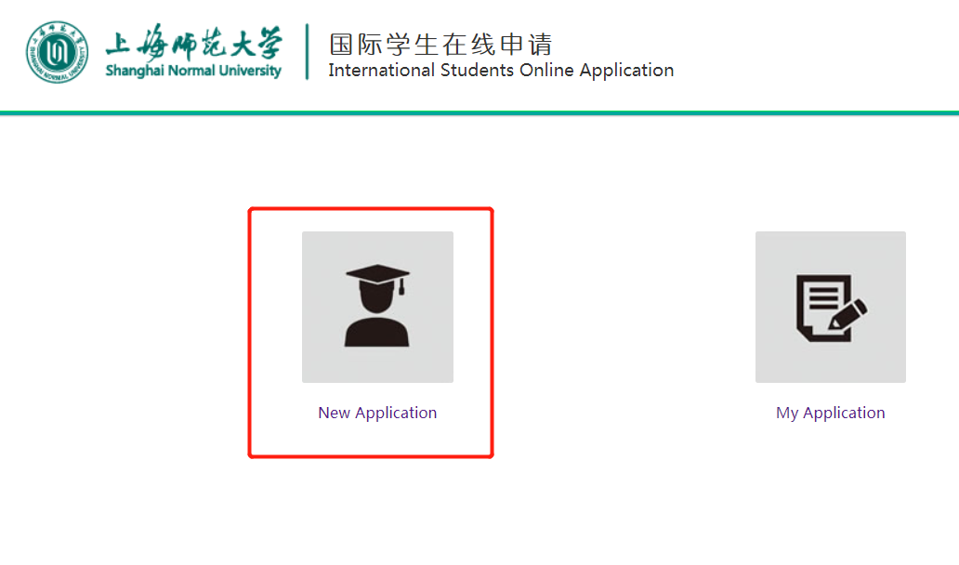

Step 4：同意“申请须知”/Agree to the application guideline
仔细阅读“申请指南”并在底部选择“已经阅读完规章制度并且同意”，点击“下一步”/Please read through the application guideline with due attention, choose “ I have read and agree to the regulations” and click “NEXT” for next step.
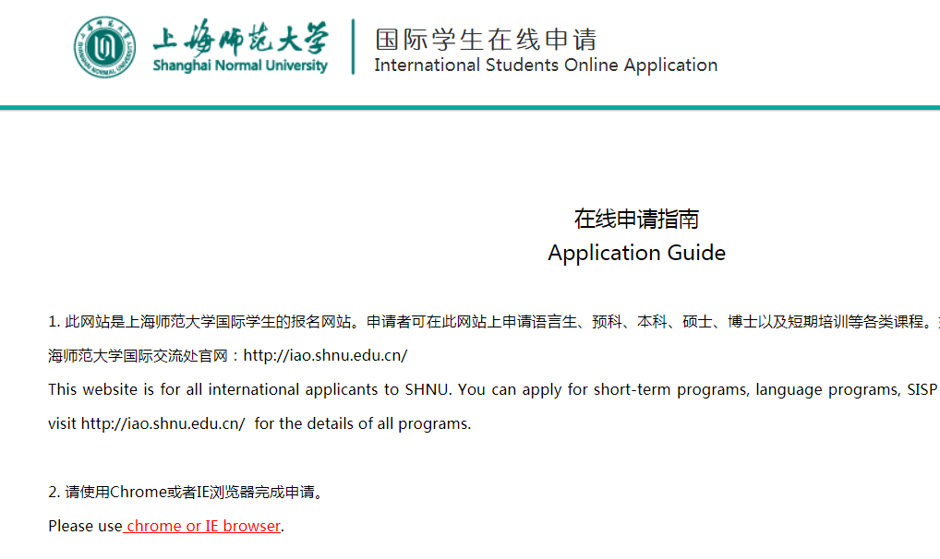
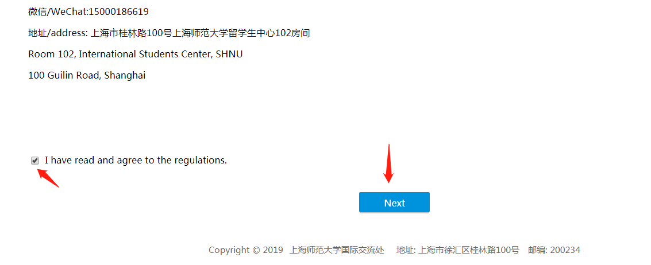

Step 5：选择申请项目/Choose the program you are going to apply
我们的项目主要分为下面八种，请务必选择正确的项目种类/The programs you can choose are listed below. Please make sure you select the right category.
- 语言生/Language Students:所有申请半年或一年及以上语言学习项目的学生/for all long-term language program students (6 months or more)
- 本科生/Undergraduate：所有申请本科项目的学生/ For all undergraduate program applicants
- 硕士研究生/Graduate：所有申请硕士研究生项目的学生/For all master degree program applicants
- 博士研究生/ Doctorate Graduate：所有申请博士研究生项目的学生/For all doctorate program applicants
- 预科生/Preparatory Students：所有申请上海市外国留学生预科项目的学生/For all SISP applicants
- 交换生/ Exchange Student：所有校际交流交换学生/ For all exchange program with partner universities.
- 短期生/ Short-term program：所有短期项目，包括暑期3S项目/ For all short-term programs, including Shanghai Summer School (3S)
- 普通进修生/General Advanced Student：所有申请本科、硕士进修项目的学生/ For all non-degree undergraduate or graduate studies.
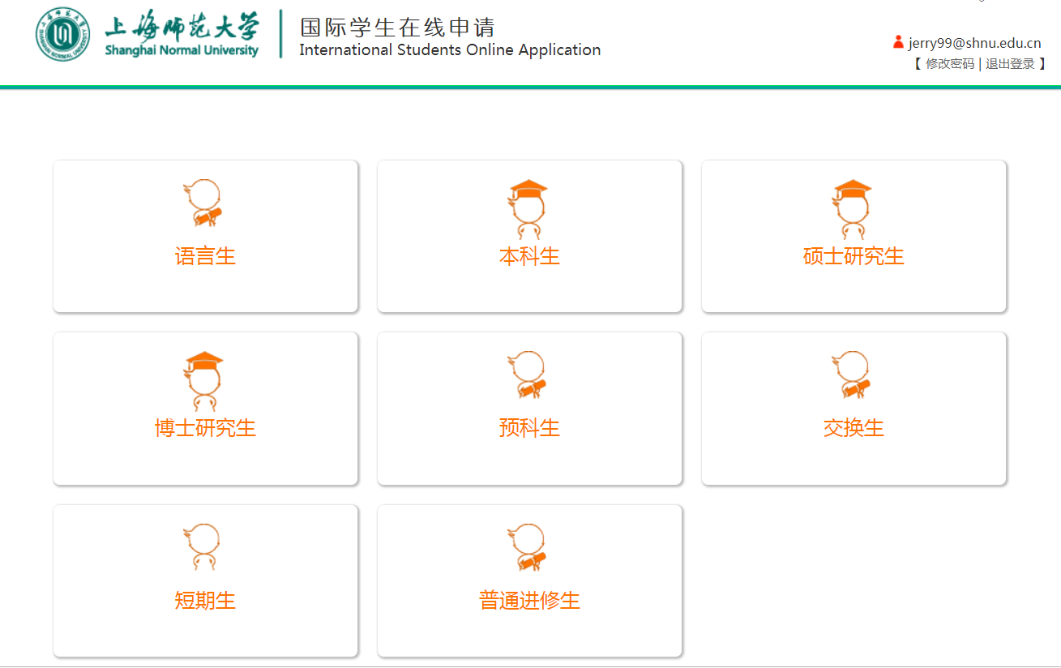

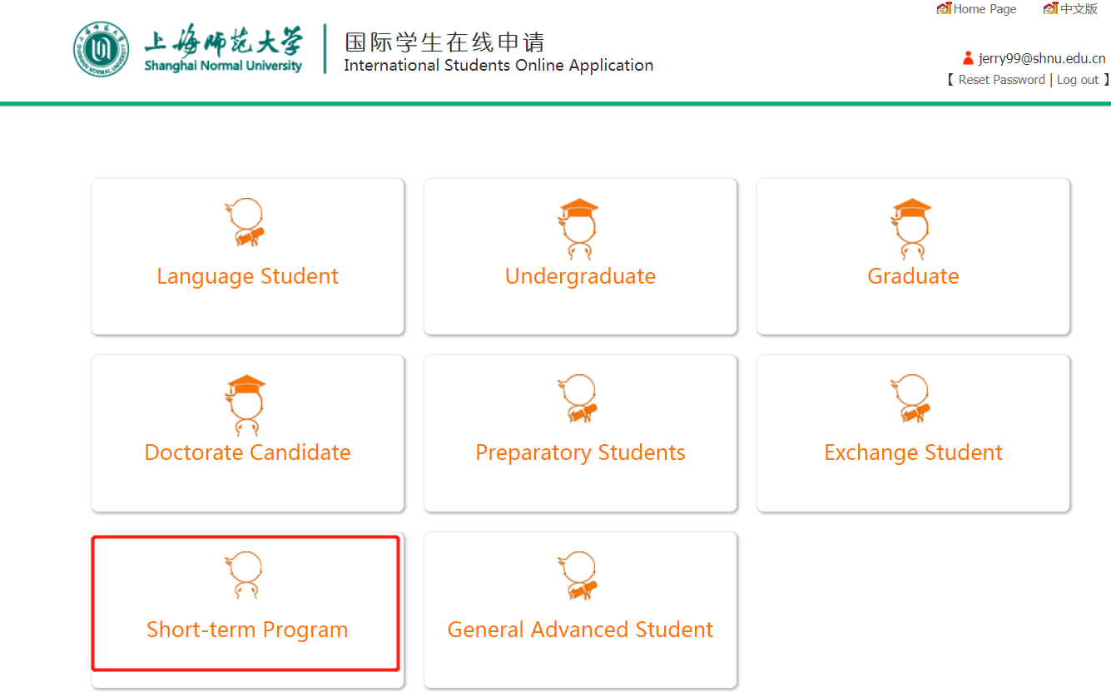

Step 6：选择授课语言、学习期限和专业/Choose the teaching language, study duration and major

授课语言/Teaching Language：汉语或英语 Chinese or English
学习期限/Study Duration：这个取决于你选择的专业，非常重要，请提前查好/It is related to the program you will apply. Please make sure you have the right info。
- 对于申请对外汉语学院汉语言或汉语国际教育留学生本科专业的学生，请务必提前确认好要就读的年级；All applicants to the undergraduate programs (for international students only) at ICCS must ensure the right grade you are going to study.
- 对于申请硕士项目的学生，请务必提前确认好自己申请的专业的学习期限，具体请参考硕士专业目录/For all graduate programs, the study duration depends on the major and program category. Please refer to the program list for graduate studies at SHNU.
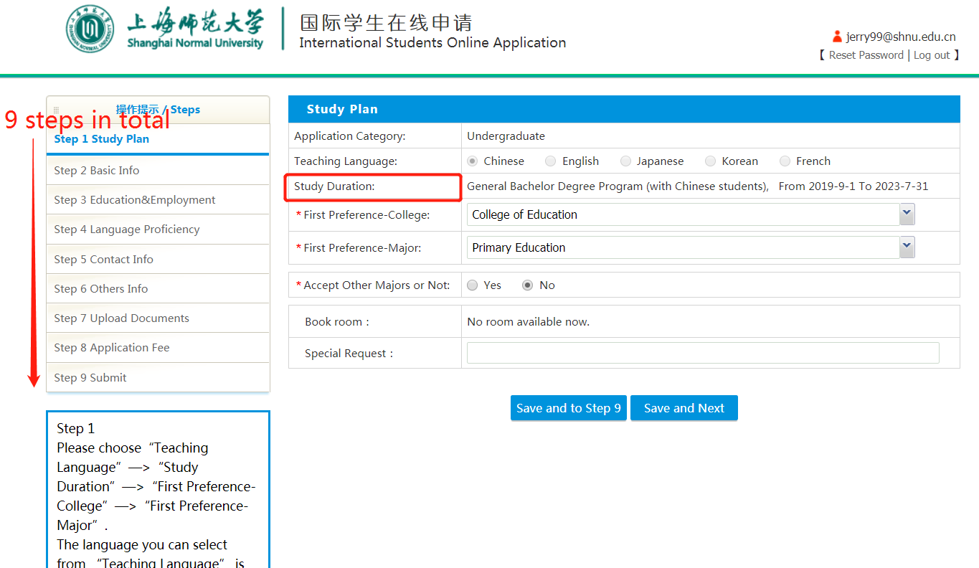

Step 7：上传资料/upload documents

请提前扫描好需要上传的文件后再申请。
We strongly recommend you to scan all the application materials before you start this online application.
1) 护照扫描件/Scan copy of your passport information page
2) 2寸个人证件照/ Passport-sized Photo (4cm*3cm)
3) 毕业证书扫描件/Scan copy of your Relevant Academic Certificates
4) 成绩单扫描件/Scan copy of your transcripts
5) 推荐信扫描件/ Scan copy of the recommendation letters
6) 报名费支付凭证/Scan copy of your application fee payment
7) 其它申请材料扫描件/ Scan copy of other relevant application files

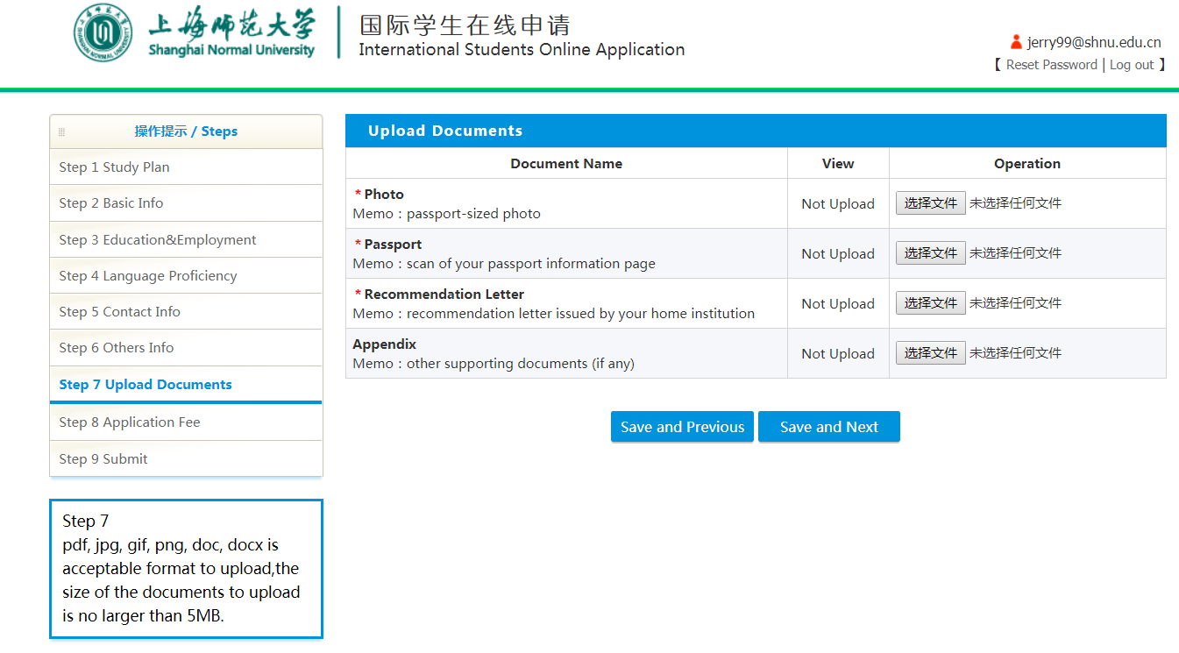

Step 8：提交申请/submit
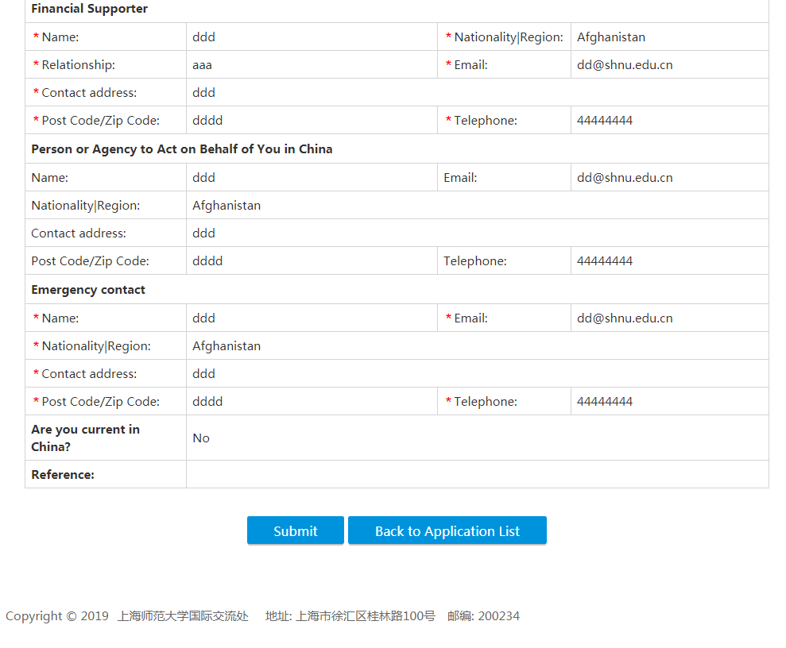

如果你已经准备好了，那现在就开始申请吧！Please start your online application now~

在线申请网址/online application Website：https://apply.shnu.edu.cn

如果在申请过程中遇到任何问题，请随时和我们联系。 Please feel free to contact us if you meet any problem in the application.

联系人/Contact:
蔡老师/Ms. Karen CAI
TEL: +86-21-64323905 E-MAIL: karen@staff.shnu.edu.cn

钱老师/Ms. Yuki QIAN
TEL: +86-21-64323111 E-MAIL iec@staff.shnu.edu.cn

International Students Office
Shanghai Normal University
100 Guilin Road.
Shanghai, China
200234

